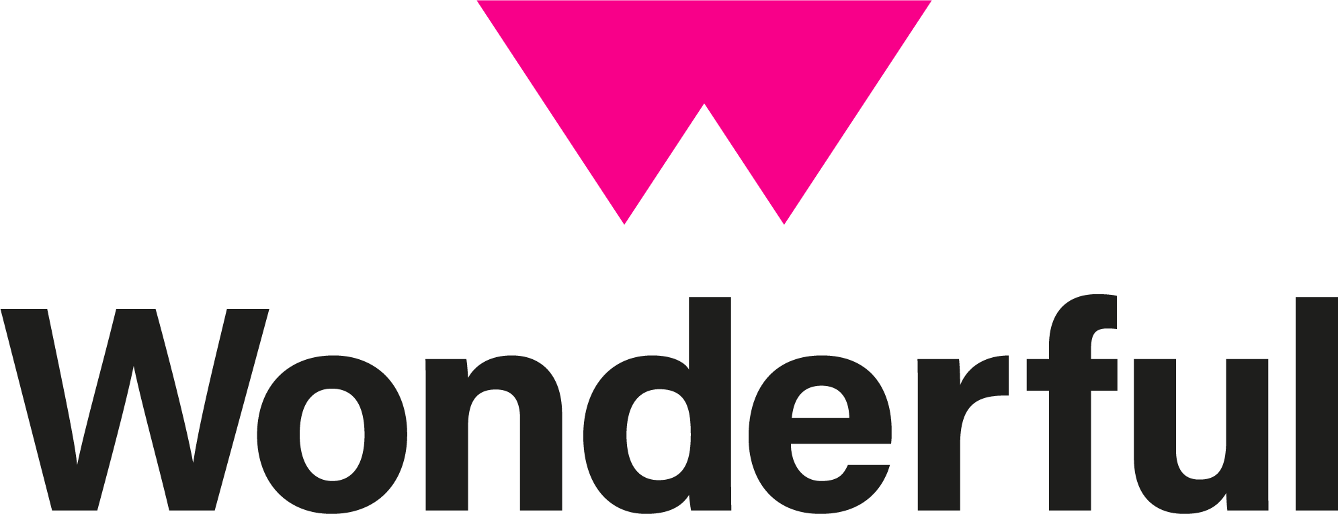

Document: Mid/Senior Creative UX/UI Designer

Role Start Date: Oct 2025

Author: Philip Hansen

Version: 1.0

A Wonderful Job Description:
Mid/Senior Creative UX/UI Designer

Agency Overview:
Wonderful is an award-winning agency that is built on trusted reputation and superior digital and creative services for Start-Ups, SME’s, large corporate organisations and government clients. We have worked with big brands such as Getty Images, InPost, Wahl, RS PRO & Mind to name a few! Wonderful is renowned for providing game-changing creative solutions that deliver results and business growth.

Our company culture and ethos are important in who we are and what we deliver. Our values of Clarity, Collaboration and Growth drive our continual desire to grow and improve and being a BCorp motivates us to create the environment that empowers and challenges our Wonderful people to do great work for great impact. Working for Wonderful doesn’t put you in a box, there is always opportunity to develop your skills and expand your experiences.

We are a remote first agency with a hybrid-working policy that brings the team together in London at least once a month.

Job Description:
We are looking for an excellent digital designer that is as comfortable with design thinking as they are with design execution. The work we do is primarily designing and creating digital, platforms, products and experiences so the ability to link strategy to exciting creative execution is essential. You will be able to demonstrate your ability to work with a client through a UX process to bring web platforms and digital experiences to life.

You will be comfortable working as part of a multi disciplined team, collaborating with different stakeholders to deliver the final outcome. This will mean the ability to communicate your thinking is important both internally and externally, with a positive attitude towards the process that encourages innovation and high standards.

Practically this will mean you will need to have proven agency or relevant experience, for at least 5 years and a portfolio of projects that demonstrate your ability to deliver exciting digital design projects.

This role will best suit an experienced designer that is looking to make the next step up in their career. You will be working with exciting brands, in a growing agency, that is actively involved in the industry, with a rapidly rising profile.

Requirements
- Proven agency experience as a UX/UI Designer
- Portfolio of excellent quality digital design projects
- 5 years of agency experience
- Clear design thinker and excellent executer
- Up-to-date knowledge of UX/UI process, trends and best practice
- In depth experience with design tools such as Figma and Adobe CS
- Collaborative; strong communication skills to work with internal and external stakeholders
- Wonderful people - positive, growth minded and excellent at what you do
- Good time-management skills - we deliver on time
- Degree level design qualification

Desired skills:
- Motion experience using After Effects or similar
- A proactive and creative use of AI tools
- Excellent written and verbal English.
- Confident, dynamic, ambitious and creative & able to act quickly on new ideas.

Benefits:
- 23 days holiday per year.
- Up to 3 additional volunteering days per year.
- Company pension.
- £300 training budget per year.
- £300 technology and home working budget in addition to laptop provided.
- Industry leading employee perks scheme including rewards, bonuses, discounts, freebies, health & wellbeing offerings and more.
- Regular team events & away days.
Remuneration
Your starting salary is £35,000 - £38,000 depending upon experience. Your basic salary will be reviewed annually. After 1-year of service, you will be included in the company bonus scheme of up to £3,600 tax free.

To apply for this role send your CV and portfolio to recruitment@bewonderful.co.uk

